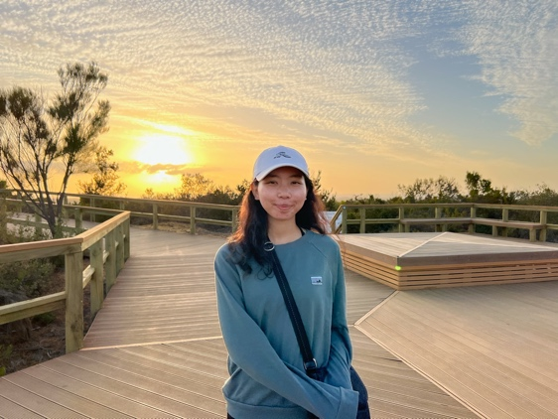
Below, The Fellowship of Australian Writers
WA intern CAMELIA ELLESHA NAZRI recommends a collection of reads by Western
Australian authors which represent the
rich cultural diversity of our state. Camelia studies linguistics at the University of Western Australia

Children

Noongar Boodja Waangkan: Noongar First Words, written by Jayden Boundry and illustrated by Tyrown Waigana (Publisher: Fremantle Press)

The Noongar language of the Aboriginal people in the south-west of Western Australia is depicted through the illustrations of first Noongar words that express themes, such as boodja (country), moort (family), and bonar (seasons), and many more. This illustrated book is a wonderful introduction for both children and adults alike to learn the language spoken on Noongar Boodja.

Dingo’s Tree, written and illustrated by Gladys Milroy and Jill Milroy (Publisher: Magabala Books)

A poignant tale that centers around Dingo, Wombat and Crow as they work together to protect Little Tree whose branch holds a precious raindrop. Told against the backdrop of a mining project, Dingo’s Tree illuminates the immense harm brought upon the natural habitat on Country by these destructive activities and the importance of helping those who call this place home.

Hugo: The boy with the curious mark, written by Yohann Devesy and illustrated by Manuela Adreani (Publisher: Red Paper Kite)

Hugo was born with a curious mark that reflect the colours of the rainbow. Feeling unhappy that no one else had a rainbow mark, he boards a train to venture for someone who might. His adventure takes him to the beach, the bustling city and even a carnival filled with colourfully-dressed people – though none had a mark like his. Suddenly, he makes a discovery that allows him to embrace the beauty in being different.

Teens

Dirrarn, written by Carl Merrison and Hakea Hustler (Publisher: Magabala Books)

After flying far from her home in the Kimberley and to her private boarding school in Perth, a Jaru child called Mia navigates her way through different ways of living, speaking, and interacting with people. Though faced with a longing for home, Mia gradually begins to embrace the experience of being on your own and learning new things. Whether at home or a strange place, Dirrarn proves it is possible to live the best of both worlds.

I Am The Mau & Other Stories, written by Chemutai Glasheen (Publisher: Fremantle Press)

Chemutai Glasheen gathers inspiration from her African background as she weaves together a collection of short stories that delve into different aspects of Kenyan
society and identity. The celebration of a surprising koito, perseverance of the Ogiek in protecting their home in The Mau, and weaving of viondo by the Taita women, are some of the stories that portray these diverse experiences.

The History of Mischief, written by Rebecca Higgie (Publisher: Fremantle Press)

Following their parents’ death, Kay and Jessie move into their grandmother’s uninhabited home. One day, the sisters find a mysterious, black book: The History of Mischief. Filled with 2,300 years of history about the magical acts of mischief wielded by its practitioners, these stories extend across different parts of the world, including Ancient Greece, an underground salt mine in Wieliczka, and the Ethiopian empire in Addis Ababa. As young Jessie researches their historical accuracy, she begins to draw a connection with the real people that surround her life, leading her to get closer to the truth about the real mischief behind the book and the stories within them.

Adults

Paradise (point of transmission), written by Andrew Sutherland (Publisher: Fremantle Press)

Told in three parts: narrative, metaphor, and paradise, Queer Poz writer Andrew Sutherland produces a series of poems that illustrate his experiences of being diagnosed HIV positive. Tracing his departure from Singapore back to his birthplace in Boorloo (Perth), Sutherland gives a reflective insight into the emotional and physical changes that occur while living as an individual with HIV.

Debesa: The Story of Frank and Katie Rodriguez, written by Cindy Solonec (Publisher: Magabala Books)

Situated in the West Kimberley, an isolated sheep station becomes the ‘idyllic home’ of Frank and Katie Rodriguez and their four children whose heritage spans a blend of Aboriginal, Spanish, Indian and English cultures. Debesa, built by the perseverance of the couple alongside their close friends and families, is represented in connection with the histories of the children’s own ancestors whose past encompassed experiences of migration, forced separation and discrimination as well as their resoluteness in maintaining their Nigena identities, stories, culture, and language.

The Historian’s Daughter, written by Rashida Murphy (Publisher: UWA Publishing)

Growing up in front of the Sahyadari Hills – in the ‘disorderly’ home inhabited by gossipy aunties, the imprisoned Rani Aunty, a foreign guest, the Magician, the Historian and her three siblings – was the norm for young Hannah. One day, both the Magician and Rani Aunty disappear. Later, her sister Gloria, goes missing too. The Historian makes the decision to move Hannah and her two brothers to Perth. Faced with the desire to uncover her missing relatives’ whereabouts and the secret kept in Rani Aunty’s tin box, Hannah’s search leads her to discover the truth about herself and the family that raised her.

Acknowledgments
I would like to extend my gratitude to Fremantle Press whom I sought for
advice on books they might recommend for me to read and include in my book
recommendations. I thank Chloe Walton for providing me with a
generous list of books and directing me towards additional resources on their
website including samples, book club notes, and teaching notes.

Finally, thank you to the local publishers and the authors of Western Australia whose stories represent the diversity of voices that make up the heart of this region.

